Operator UI design

DOC. No.: | REV.: 00 |  |  | PRODUCT:
TITLE: Operator UI design |  |  |  | Project:
Prepared by: | Donald huang |  |  | Date:
Remark: | Approval:
Remark: |  | Department | Title |  |  | Signature
Remark: | 1 | Electronic R&D
Remark: | 2
Remark: | 3
Remark: | 4

Revision | Description of Change | Author | Date
01 | First version | Donald Huang | 5/26/2010

1. Overview 4
2. Major functions 4
3. User Levels 5
4. UI of the Operator 5
4.1. Fill 5
4.2. Statistics 6
5. Technician & engineer UI 7
5.1. Menus 7
5.2. Machine 7
5.2.1. UI elements 8
5.2.2. Component detail dialog 8
5.3. Products 10
5.3.1. Select product 10
5.3.2. Product parameters 10
Component capabilities & Constraint between parameters 10
Volume/Dosage/Quality 11
5.4. Menu (Editor) 11
5.5. Vending 11
5.6. Others 11

Overview

The operator menu design target is to make a comprehensive, easy to use one. Operators need little train to manipulate the machine.

To full fill this, following measures are to be taken:
- Everything can be done on the touch screen without PC connecting to it.
- A graphical component UI, each item corresponds to the real one in the machine.
- Hide low level parameters
- Smart parameter adjustment according to high level parameter changes. E.g. adjust topping dosage of a product will automatically adjust canister duration, etc. parameters.
- Integrate customer menu editor.
- Well define the authorities. Three levels of menu are used.

Major functions

- Component related
  - Component status
  - Component adjustment
  - Component test functions
  - Component Calibration
  - Component statistics
- Product related
  - Price list
  - Volume/Dosage/quality
  - Product statistics
- Customer menu editor
- Filling
- Maintenance
  - Rinsing
  - Purification
  - Decalcify
  - Filter
- Credit devices
  - Show channels
  - Tubes count
  - Manual dispense
  - Reinvestment
  - Credit report
- Vending
  - Vending setting (free vend, auto start, single vend, card first, revalue, overpay take-in)
  - Turnover, etc report since init
  - Turnover, etc report since reset
  - reset
- Others
  - Password
  - Language
  - Standby policy
  - Reset
  - Log
  - LCD backlight
  - Backup/restore

User Levels

There are 3 levels of users: operator, technician and engineer

Operator is also called filler, is a person who do everyday maintenance to the machine. An operator’s major duties are: clean the machine, fill ingredient, and collect coins/bills, collects sales data. An operator will call for technician if machine run into malfunction.

Technician is the one who fixes the machine malfunction and do some adjustment to the machine. He could run some test to machine components and products, making sure the machine run properly. He could also do some modification to menu, adjustment and recipes, etc.

Engineer is the machine master for the operation organization. On top of technician’s rights, an engineer could do some further jobs, e.g. initialize machine, setup advance settings (vend mode, payment mode, etc.), perform more functions and adjustment to the machine, clone machines, etc.

UI of the Operator
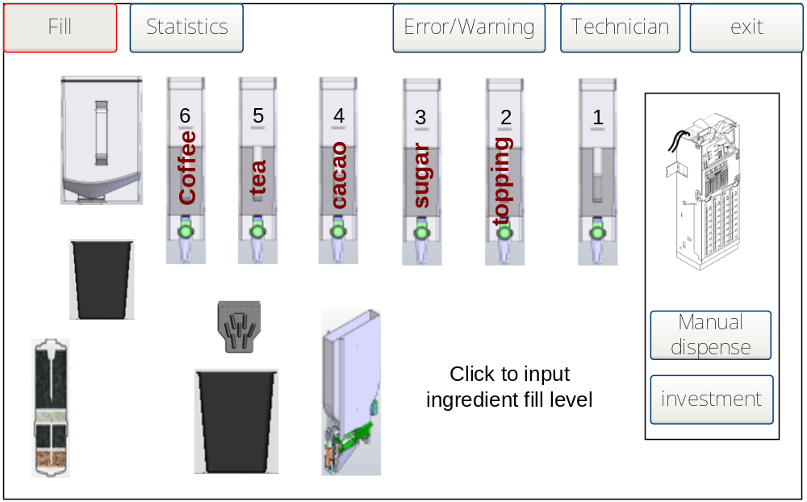

There are two major UI for operator: Fill and statistics.

Fill

The above UI is fill UI. Several jobs can be done here:
- Canisters will show index and ingredient names
- Click on the canister and bean container will popup a fill ingredient dialog (below figure) to input new ingredient fill level. Canister and bean container will show roughly current ingredient level in ingredient’s colour.
- Waste bin and drip tray icon will show there status (placed correctly or missing).
- Click on the nozzle icon will show the nozzle pipes connection plan for this machine. It is for operator’s reference when he unplugs the pipe for cleaning.
- If a changer presents, operator can do manual dispense and coin investment in this UI.
- Error/Warning button (icon) will flash if there is error/warning. Click on it will show the error/warning message. Operator could report it to technician.
- The technician button is a technician/engineer UI entrance. Click it will prompt to input password. Input technician will go into technician UI; input engineer password will go into engineer UI. If two passwords are the same, it will go into engineer UI.
- Exit button go back to the customer UI.
- Filter icon shows how much the filter consumes, time/volume left for filter renew

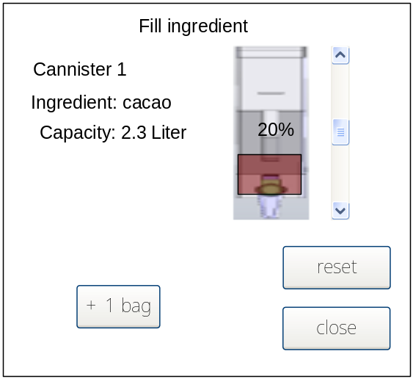

The fill ingredient dialog shows the canister/bean container information. Also, it provides 2 ways to modify ingredient level: by bag or by percentage (the scroll bar). A visual feedback of ingredient in canister will show correspondingly.

Statistics

Statistics UI uses a list to show turnover for all products. This information is for the operation organization which doesn’t provide EVA pda to collect sale data.

“All products” are referring to the products in customer menu, which are sellable.

The statistics list contains:
- Product name.
- Product count since init
- Product count since reset
- Product turnover since init
- Product turnover since reset

Statistics UI should also provide a “reset” button which protected by password.

Note: other detail statistics data are transfer by EVA PDA.

Technician & engineer UI

In technician and engineer UI, there is no Fill UI. Close and open the door again can access to the operator UI.

Technician UI hides some advance functions of the engineer UI.

Menus
All functions are integrated into 5 menus:
- Machine
- Products
- Menu
- Vending
- Others

Machine
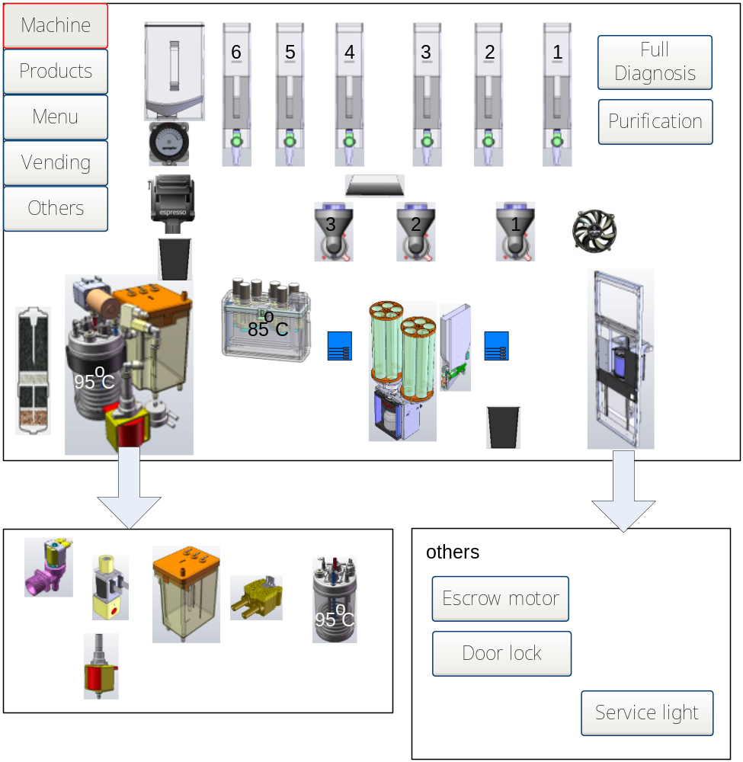

Machine menu shows a graphical UI which integrates component related functions. Moreover it could show the warning/error/status of components at the same time.

Graphical interface contains most mechanical components/items in single view; complex items will goes into additional picture.

To show machine with component image make it more comprehensive, little training is needed for new technician.

However, there is drawback for it. All UI will be highly customized for the given machine.

UI elements
- Error and warning visualization: the component with error or warning will flash with different background colour (yellow/read for warning/error).
- When some components with lifecycle monitoring, e.g. water filter, brewer, valve, reach there lifecycle trigger, this component will flash too. (with different colour)
- Current water temperature of PIB and boiler will show over them.
- Canister and mixer will show index
- “Full diagnosis” button will perform diagnosis for every component. Every component could perform diagnosis in its sub dialog.
- “Purification” button is for mandatory run purification. (rinsing is in brewer sub dialog)

Component detail dialog

When click a component, component detail dialog will pop up.

All information and capable actions are integrated into this dialog. Operator doesn’t need to navigate to other menus to get the job done.

They are:
- Related data and status:
  - Water temperature for PIB and boiler
  - Working statistics for lifecycle monitoring components: e.g. working hours and water amount for water filter; working hours and grams of bean for brewer, etc.
  - Warning for change lifecycle monitoring components and a button (with text like “filter renew”) for reset component statistics.
- Warning & error
  - Warning & error text
  - Help and guide to fix the problem (graphic, text, video)
- Component adjustment: global parameter, for all products.
- Component diagnosis button
- Calibration button
- Other test button

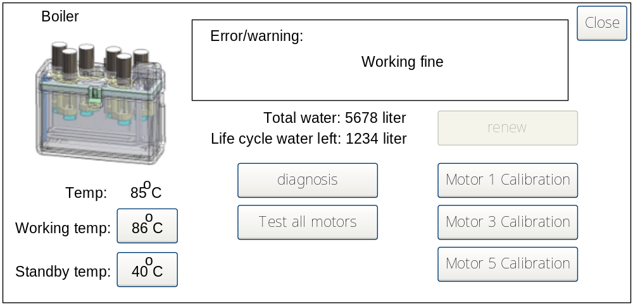

The above figure is the detail dialog for PIB. Different components’ detail dialogs are different.

Products

Select product
There are two types of product names which might make operator confuse:
- Product names show on the customer menu (multi language)
- Product names from MDF

An operator in most case handles the first one. The second one will only be used in menu editor, mapping the first one to the second one, which will be called “original product name”.

Select product UI should be the same as customer menu, which make it looks consistent. The product name should use the same language with the operator menu setting. If no language matches, use the first one.
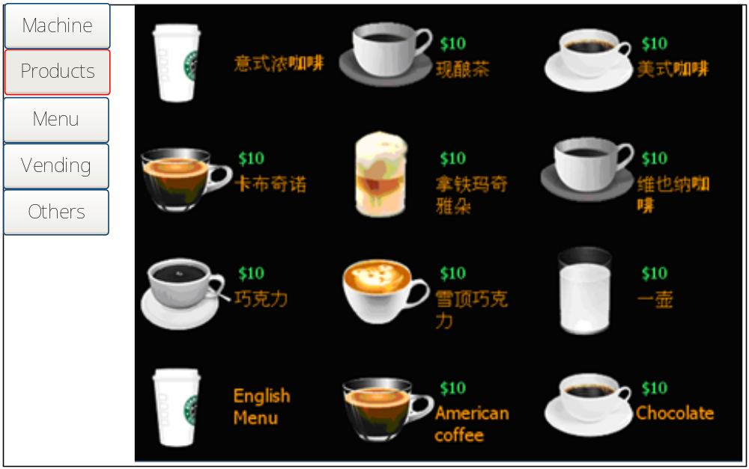

Product parameters

Technician and engineer tune the product parameters to make different taste product. It is the place they spend their major time.

Component capabilities & Constraint between parameters

Product parameters are: recipe and component adjustments to the product.

However, there are some limitation and relations between parameters which are cause by:
- Component capabilities
- Constraint between parameters

Component capabilities and parameters constraints are mostly relate to instant part of a product. ES and cooling part of products are measured by flow-meters. The dispensing time is not adjustable.

Component capabilities are the min and max speed a component gives out ingredients. Following components have these limitations:
- Canister: gram/second
- PIB: ml/second

A canister’s capabilities are affected by many factors including: ingredient density, canister shape, solenoid shape, etc.

Constraints between parameters are derived from component capabilities:
- Canister duration limitation = ingredient weight / canister capabilities
- Instant water duration limitation = water amount / PIB capabilities

On the contrary, ingredient weight is limited by canister duration; water amount is limited by the water duration.

According to the above discussion, the recipe and adjustment UI should limit canister duration, ingredient, water amount and water duration.

Note: In XA version of operator menu, operator usually adjusts ingredient dosage or canister duration that exceeds the canister’s capabilities, which cause “dosage error”.

Volume/Dosage/Quality

Operator can change product’s property by 3 means: volume, dosage and quality. Any other parameters to products can not be changed individually. This idiot way to adjust product make machine simpler, product quality more controllable.

Volume is the water part of a product.

Menu (Editor)

Menu editor must support input for many languages. There are some limitations concerning input method for the STUM to integrate menu editor
- Touch screen is not sensitive enough for virtual keyboard’s small letter button
- It’s difficult to customize WinCE’s virtual keyboard and input panel. Huge effort must be taken if develop own input method for dozen languages.

An alternative way to edit menu without a PC is to edit in smart phone. Phone is popular nowadays. Phone always has input method for local languages. Bluetooth or IR can be used to transmit menu/mdf file.

Menu editor functionalities:
- add/remove group; edit name, icon
- add/remove product; map mdf product to the product; edit name, icon;
- edit adjust dosage page item (ingredient, cup, etc.)
- select languages

Vending

Others

